Week 5 Assignment

Abstact vs Interface

Brendan McCullagh

ENTD 381

Prof. Mujeye

For this week we are discussing the differences between an abstract class and interface. In a nutshell, both are used to achieve abstraction, But only an abstract can utile eyes access modifiers such as private or public. one of the other key differences between the two Is that an interface supports multiple uses of inheritance where is an abstract class cannot. Be instantiated. An abstract can take advantage of using both abstract and non abstract methods were an interface can only have abstract methods. An interface cannot provide any implementation either whereas an abstract can.

Below is an interface test for a Taco Tuesday

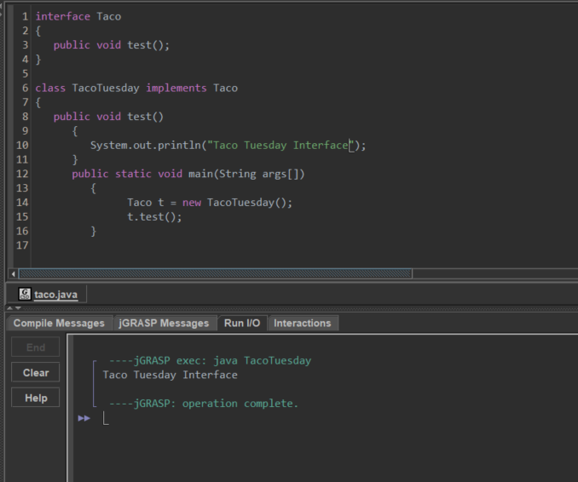

Below is an abstract for Taco Tuesday:

